HOUSING FORECAST FOR RURAL AND METROPOLITAN KANSAS

By Dr. Stan Longhofer, Wichita State University Center for Real Estate

One of the questions I’m often asked is how housing markets in the rural parts of the state differ from those in the state’s larger metropolitan areas. Usually the answer is “A lot!” Over the past year, however, this has not been the case. It’s been nuts everywhere.

Figure 1 below depicts the number of home sales in Kansas counties that are not a part of the state’s five large metropolitan areas (Kansas City, Lawrence, Manhattan, Topeka and Wichita). I use these counties as a rough proxy for the state’s rural areas, understanding, of course, that cities like Hays, Emporia and Pittsburg are not truly rural. Nevertheless, the distinction between Kansas’ metropolitan and non-metropolitan counties generally reflects the strong differences between the state’s urban and rural housing markets.

Figure 1 – Home Sales in Rural Kansas

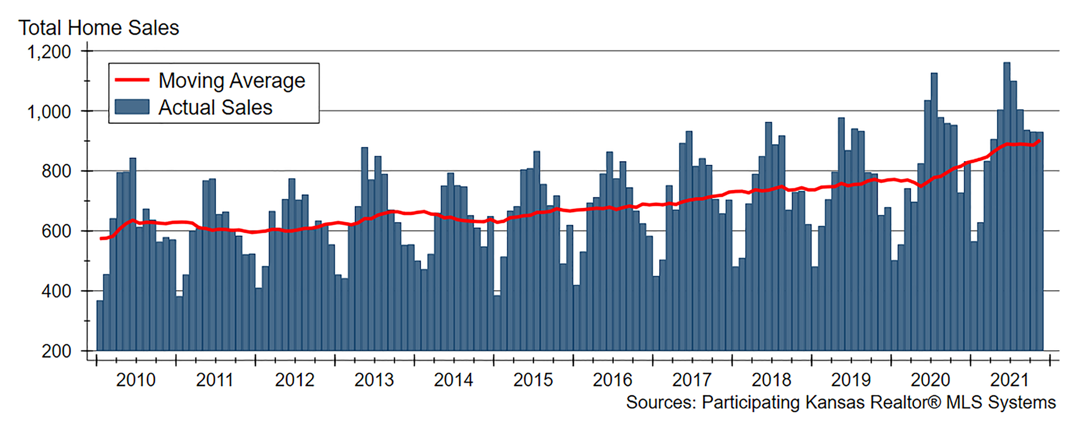

In this figure, actual home sales are depicted by the blue bars, while the red line is the 12-month trailing moving average of home sales, and is used to show underlying trends that can sometimes be masked by the seasonality of home sales. The most striking feature of this graph is the way home sales took off almost immediately after the pandemic lockdowns in early 2020. Through November of 2021, total home sales in the rural parts of Kansas were up nearly 17% compared to the same period in 2019. This torrid pace of sales is virtually unheard of in rural Kansas.

With home sales increasing at such a rapid pace, the supply of homes available for sale has become increasingly tight. We measure balance in the housing market through a statistic called months’ supply. Imagine that there were 100 homes available for sale in a particular market. If on average 20 homes per month sold over the past year, we would say that there was a 20 ÷ 100 = 5 months’ supply of homes available for sale. That is, at the current pace of sales it would take five months to work through the current inventory of 100 homes.

In urban areas, we tend to say that the housing market is balanced if there is between a four and six month’s supply of homes available for sale. Above that level the market tends to favor buyers, while markets with tighter inventories tend to favor sellers. In rural areas, it is not uncommon to have much larger inventories, so the definition of a “balanced” market needs to be adjusted accordingly.

Figure 2 shows the months’ supply for the entire state of Kansas as well as just the state’s non-metropolitan counties. The first thing to note in this figure is that the state as a whole has tended toward a sellers’ market (less than a four months’ supply) since the end of 2015. This largely reflects the conditions in the state’s five metropolitan areas. In contrast, inventories in the state’s rural counties have been much more flush. Until recently, that is.

While inventories in rural Kansas had been slowly declining since 2015, they began to drop precipitously toward the end of 2019 and now sit at the lowest levels on record. The strong pace of sales since the onset of the pandemic have served to make the state’s rural housing markets look much more like its urban markets.

Figure 2 – Inventories of Homes Available for Sale across Kansas

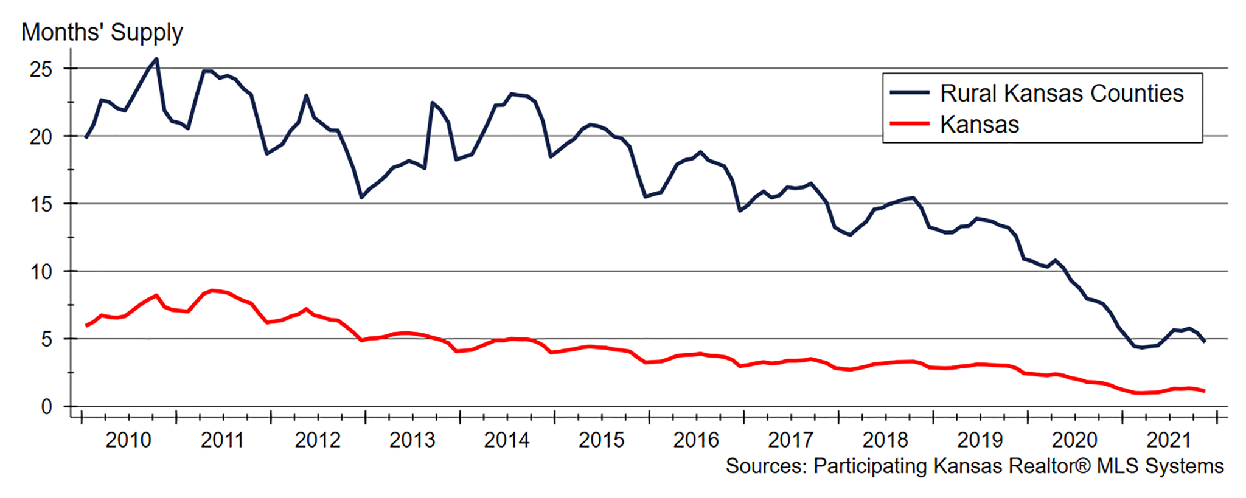

As one might expect, markets respond to strong demand and tight inventories with rapid price appreciation. Figure 3 below shows the year-over-year percentage change in the Federal Housing Administration’s all-transactions house price index for the state as a whole and the state’s non-metropolitan counties. This index uses homes that have sold more than once in order to provide a true measure of underlying home price appreciation for typical homes.

While home price appreciation across Kansas had been averaging about 5% annually since late 2016, this strong growth only reached the state’s rural areas starting in 2019. After the pandemic hit in 2020, however, appreciation skyrocketed across the entire state. During the third quarter of 2021, average annual home price appreciation across Kansas was 14.8%. This was only slightly less in the state’s rural areas, where home values rose by 13.4% year-over-year in the third quarter.

Figure 3 – Home Price Appreciation in Kansas

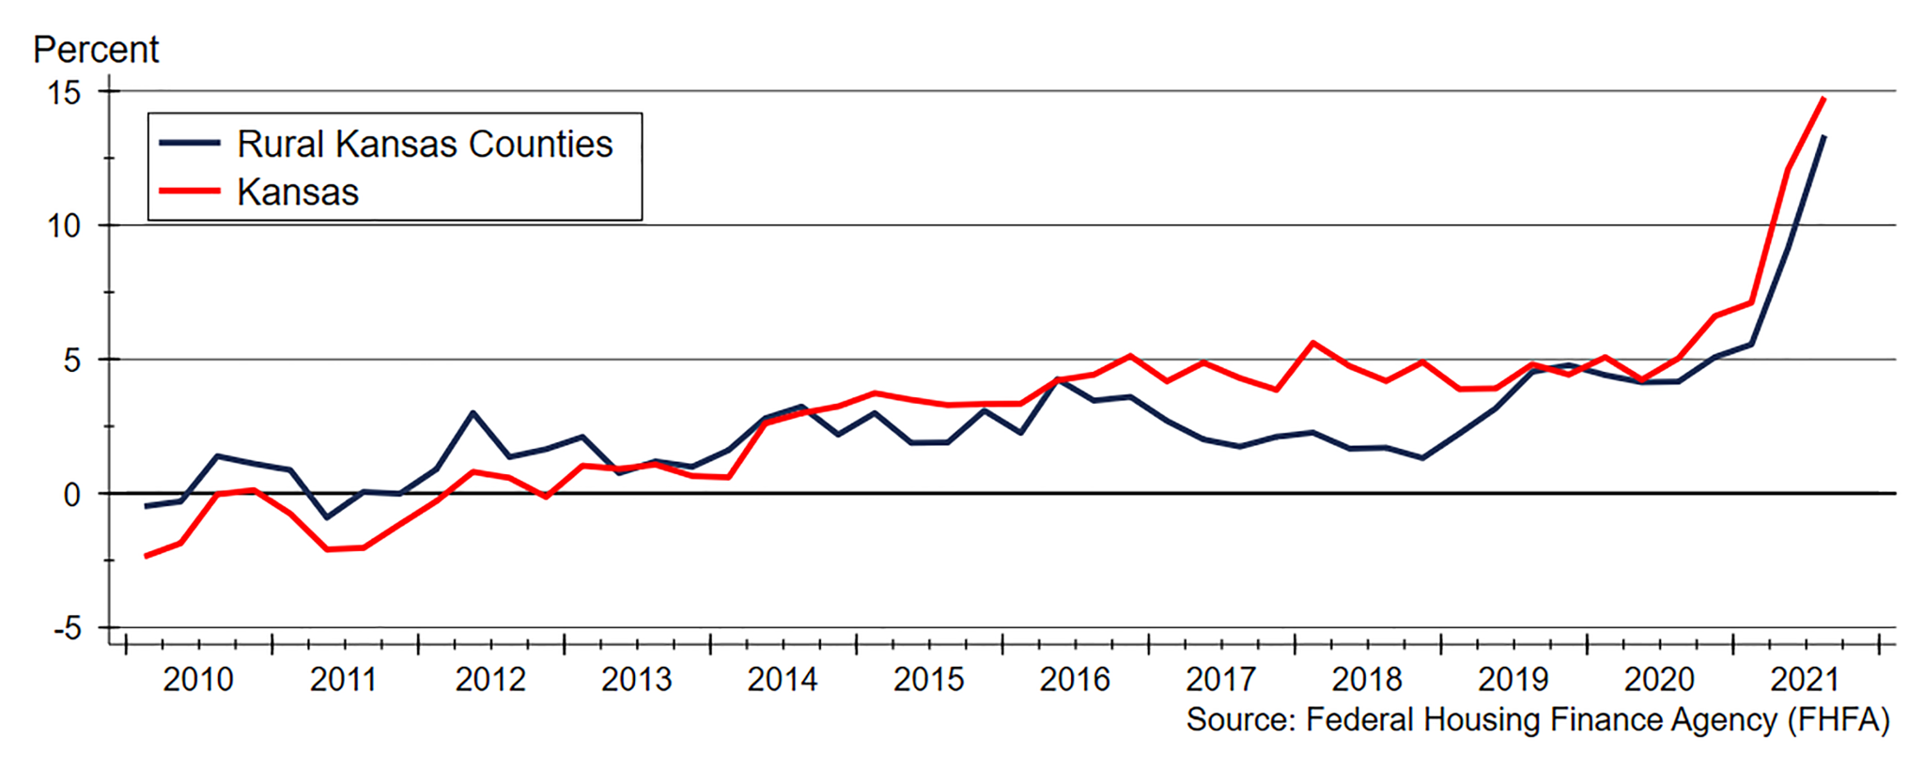

When will all of this end? Although home prices have taken off over the past two years, the underlying pressure leading to this appreciation has been building for years. New home construction never fully recovered from the downturn that followed the financial crisis. At the same time, the demand for housing has grown as more people are choosing to live alone rather than with roommates. As a result, we face a severe shortage of housing units that will take years to resolve. While the incredible pace of home price appreciation we’ve seen over the past year is likely to cool somewhat in the coming months, we should continue to see very strong home price appreciation for at least the next year, if not longer. This is true for both the state’s urban and rural housing markets. ■

*Stan Longhofer holds the Stephen L. Clark Chair of Real Estate and Finance in the W. Frank Barton School of Business at Wichita State University and is the founding director of the WSU Center for Real Estate.*